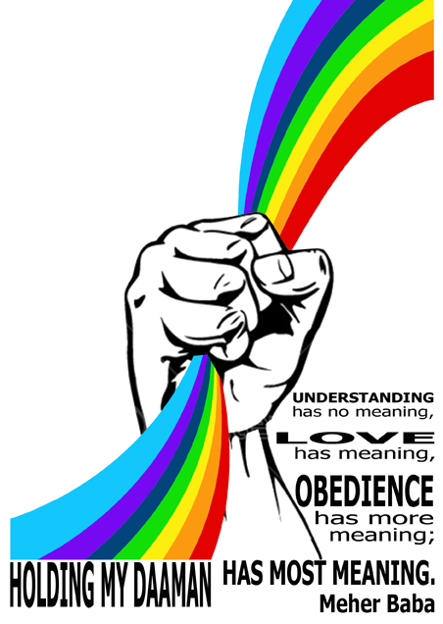
We invite young adult Baba lovers from around the world to the Meherabad Young Adult Sahavas 2012.
What: IN JUNE, 100 young adults from all over the world will gather at Meherabad to spend seven days together in the company of the Ancient One. The keynote of the sahavas is the celebration of Meher Baba’s love through sharing, creative expression (such as art, music, and drama), and service at Meherabad.
Who: Young Adult Baba Lovers from ages 18 to 35.
When: The sahavas starts on Thursday, June 21st and continues through lunch on Thursday, June 28th.
Where: Meherabad
Visit http://ambppct.org/events/sahavas.php to send your application for MYAS-2012 or search for “Meherabad Young Adult Sahavas Videos” on the Internet to see glimpses of past sahavases.

